Corstead Testing Edits
Prospect Profile and Quote Workflow
Testing round - October 1, 2026
The items below follow the workflow from creating a prospect/customer profile through building and configuring a quote. The goal is to keep the screens simple, consistent, and usable across different home-service industries.
1. Prospect and Customer Profile Setup
1. Residential and Commercial Forms Should Change Dynamically • When Residential is selected, show a residential-specific form and hide business-only fields. • Company / Business Name should not appear on a Residential profile.
• When Commercial is selected, show Company / Business Name and any other fields that are specifically relevant to a commercial account.
• Do not show unnecessary fields from the other account type.
2. Automatically Format Phone Numbers
• The user should be able to type a cell phone number as digits only.
• Corstead should automatically format the number into the standard phone-number format. • The user should not have to manually enter parentheses, dashes, spaces, or other punctuation.
3. Replace Window and Property Details With Custom Fields
• Rename the current Window and Property Details section to Custom Fields. • This section needs to be industry-neutral so Corstead can work for any service company, not only window cleaning companies.
• Admins should be able to create the custom fields their company wants to track. • Once an Admin creates a custom field, it should automatically appear on every prospect and customer profile within that company account.
• Support multiple field types, including free text, dropdown/select, number, date, and checkbox. • These custom fields should later be searchable/filterable so a company can categorize and find prospects or customers based on the values entered.
Example: a window cleaning company could create a Window Type field. Another service company could create completely different fields without Corstead forcing window-cleaning-specific data.
4. Remove Manual Lifecycle Selection
• Remove the Lifecycle selector from Account Settings.
• If a user creates a record from the Customers section, it should automatically be created as a Customer.
• If a user creates a record from the Prospects section, it should automatically be created as a Prospect.
• Do not let users manually switch a profile between Prospect and Customer from Account Settings.
Corstead LLC | Testing Edits | October 1, 2026
• Prospect-to-customer conversion should happen through the intended conversion workflow after estimate acceptance, not through a manual lifecycle dropdown.
5. Rename Notes to General Notes
• Change the section title from Notes to General Notes.
2. Profile Management
6. Simplify the Delete Confirmation
• Keep a confirmation pop-up before permanently deleting a prospect or customer profile. • Remove the requirement to type the prospect/customer name to confirm deletion. • Use a simple confirmation message asking whether the user is sure they want to permanently delete the profile.
• Provide two buttons only: Delete / Confirm and Cancel.
• Keep the warning that deleting the entire profile also deletes the records tied to that profile. 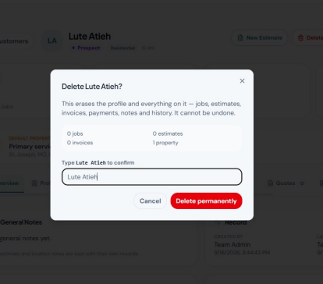
Current delete-confirmation screen. Remove the typed-name confirmation requirement and keep a simple Delete/Confirm or Cancel choice.
Corstead LLC | Testing Edits | October 1, 2026
3. Quote / Estimate Creation
7. Use Services Only for Quote Line Items
• Remove the Custom Line Item option for now.
• Quote line items should come from Services only.
• When the user clicks Add Service, open the Add from Service Catalog screen. • From there, the user can either select an existing service or create a new service. • A newly created service should be added to the company Service Catalog so it can be reused on future estimates and jobs.
8. Simplify the Service Catalog
• Keep Service Name / Title and Category as the core catalog information.
• Do not require or store a default price when a service is created in the Service Catalog. • Remove the Pricing dropdown and unit-type choices such as Flat Rate, Per Service, Per Window, Per Hour, and Per Square Foot.
• The actual price should be entered when the service is used on a specific quote or job. • In the Category area, let the user add new categories and delete categories directly without leaving the Add Service workflow.
• Services created once should remain available for reuse across profiles, quotes, and jobs. 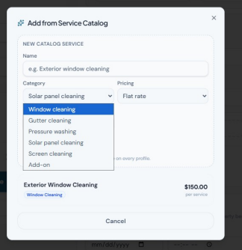
Current Add from Service Catalog screen. Keep the service name and category, remove the catalog pricing setup, and make categories manageable from this workflow.
Corstead LLC | Testing Edits | October 1, 2026
9. Lock the Service Name on the Quote, but Allow a Quote-Specific Description • The quote line-item title should display the Service Catalog service name/title. • The service title should not be editable directly on the quote.
• If the user wants a different service, they should return to Add Service and either select a different catalog service or create a new service.
• Under the service title, provide a free-text Description box.
• The description is specific only to that service on that specific quote for that prospect/customer. • The description must not overwrite the Service Catalog item and must not automatically carry forward when the same service is used on another quote.
10. Use the Following Quote Statuses
• Open
• Pending - Sent Only
• Pending - Sent and Viewed
• Accepted
• Declined
• Closed
• Keep the distinction between Pending - Sent Only and Pending - Sent and Viewed so the office can immediately tell whether the customer has opened the quote.
4. Quote Settings and Expiration
11. Move Quote Validity to Company Admin Settings
• Do not require the user to manually enter a specific Valid Until date on every quote. • Add a company-level Admin setting where the business chooses how many days a quote remains valid.
• Examples could include 15, 30, 60, or 90 days, plus the ability to enter another number of days. • Corstead should automatically calculate the quote expiration date from that company setting.
12. Expired Quotes Stay in Corstead but the Customer Link Becomes Inactive • When a quote reaches the company-defined validity period, do not delete it. • The quote should remain saved on the prospect/customer profile and remain part of the company history.
• The secure customer-facing link should become inactive after expiration.
• After expiration, the prospect/customer should no longer be able to view the quote through the link, accept it, decline it, or take any other action on it.
• Expiration affects customer access and action only; it does not remove the internal record. 13. Company-Defined Terms and Conditions
• Do not provide any default Corstead terms and conditions.
• Leave Terms & Conditions blank by default.
Corstead LLC | Testing Edits | October 1, 2026
• Add a company-level Admin setting where each business can type and maintain its own customer-facing terms and conditions.
• If the company chooses to use them, the saved terms should populate on estimates/quotes where applicable.
• Corstead should not provide legal wording or suggest specific terms. Each business is responsible for its own terms and conditions.
5. Global Time Selection
14. Use 15-Minute Time Increments Across the Platform
• Anywhere Corstead asks the user to select a time, use 15-minute increments rather than arbitrary minute-by-minute selection.
• Each hour should offer :00, :15, :30, and :45.
• Use standard AM / PM formatting.
• Apply this consistently to estimate appointment start/end times and other scheduling screens throughout the platform.
Example: 8:00 AM, 8:15 AM, 8:30 AM, 8:45 AM, 9:00 AM, etc.
Corstead LLC | Testing Edits | October 1, 2026

